**Assignment 2A**

**Singning into the Github Account**

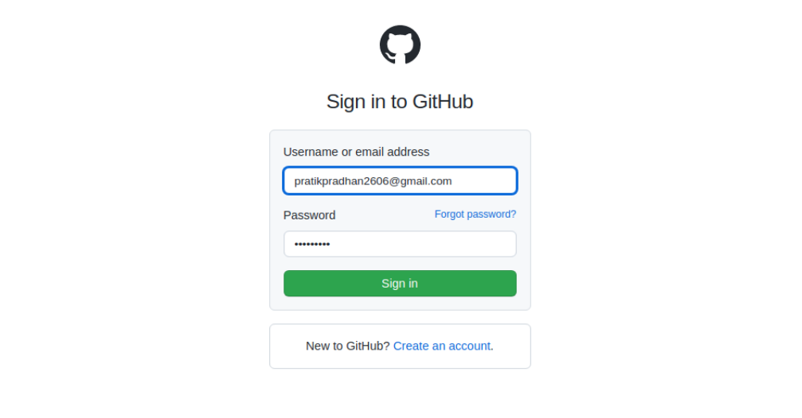

**Creating New Repository**

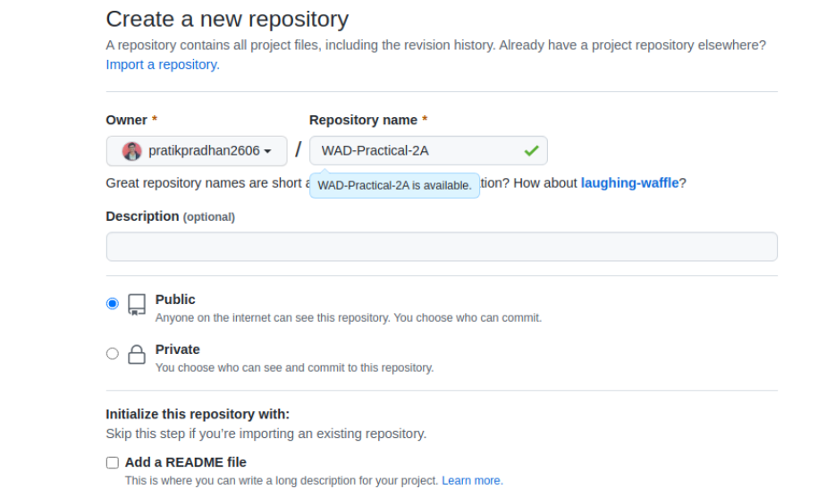

**Git Commands in Terminal for Pushing the project on Github**



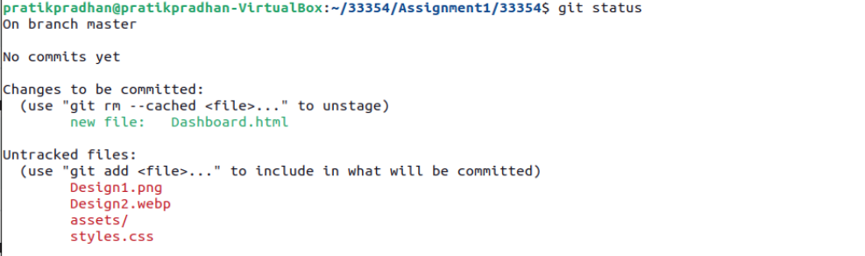

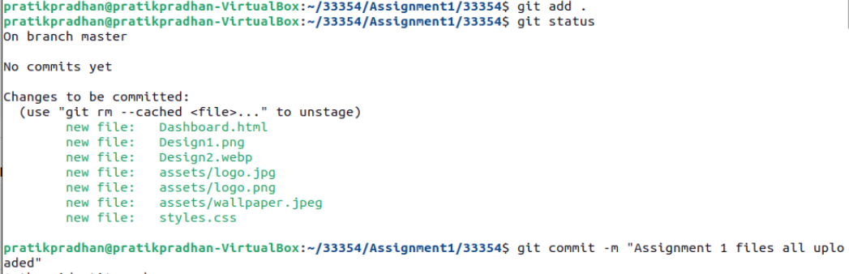

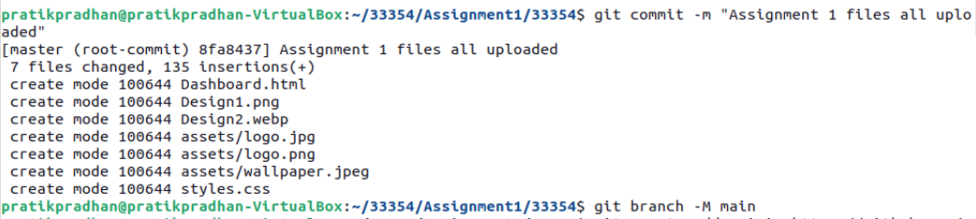



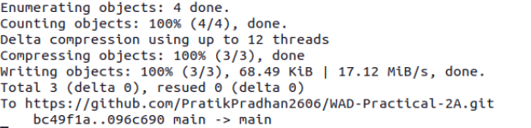

**Project Pushed on the Github!**

